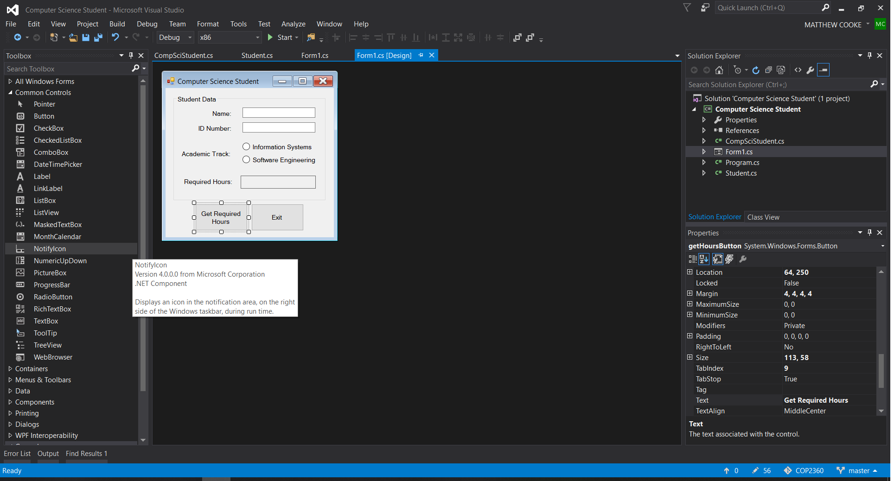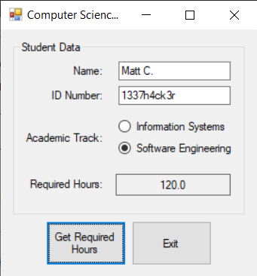using System;

using System.Collections.Generic;

using System.ComponentModel;

using System.Data;

using System.Drawing;

using System.Linq;

using System.Text;

using System.Windows.Forms;

namespace Computer_Science_Student

{

public partial class Form1 : Form

{

public Form1()

{

InitializeComponent();

}

private void exitButton_Click(object sender, EventArgs e)

{

this.Close();

}

private void getHoursButton_Click(object sender, EventArgs e)

{

//variables to hold input

string name, id, track;

//get the student's name and ID

name = inputNameLabel.Text;

id = idTextBox.Text;

//get the student's academic track

if (infoSystemsRadioButton.Checked)

{

track = "information Systems";

}

else

{

track = "Software Engineer";

}

//create a compsci student object

CompSciStudent csStudent = new CompSciStudent(name, id, track);

//display the student's required hours

requiredHoursLabel.Text = csStudent.RequiredHours.ToString("n1");

}

}

}